Background

PI report is to help QCM DC operation in performing of the physical Wall to wall count. Currently DC operation is exporting the data from Exceed and manually prepares PI report.

Objective

The PI report is to create in the hub to allow operation to print ad-hoc PI report from the hub and do not need to perform manual preparation of PI report.

Current Process

- Step 1: Export all the data from Exceed.

- Step 2: Manually prepare PI report on the MS Excel.

.

New Process

- Step 1: Go to hub, <Report> → <Cycle Count> → <PI Report> and enter location to print out the PI report for selected location.

Sample of the PI Report.

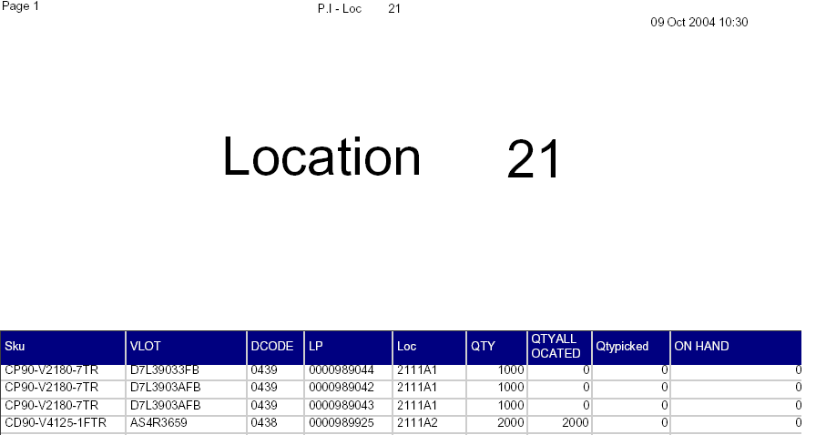

Note : Please add in “Count by : __________” and “Date : ________” at the late page.

